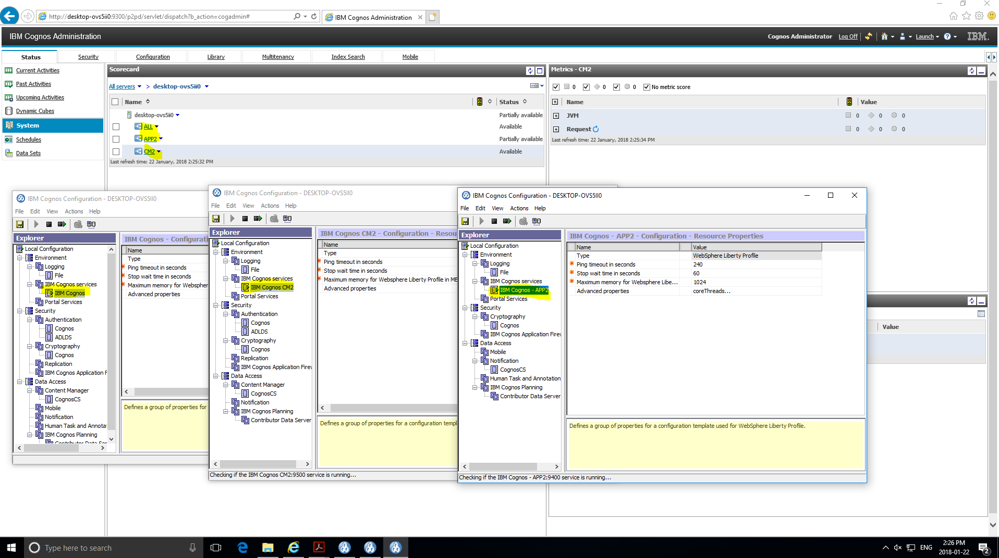

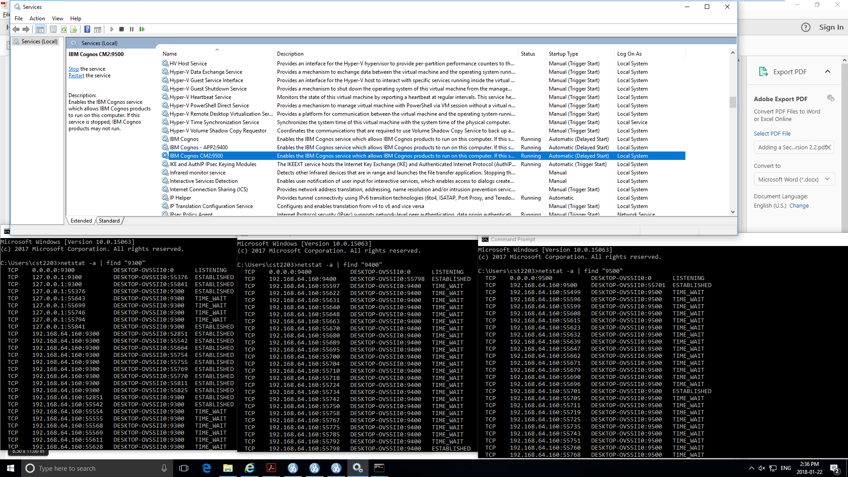

This dispatcher is: desktop-ovs5ii0:9300/p2pd/servlet/dispatch

GUID=48F119D6-894F-403E-8E70-3CC28CDA8D3B

Using CM: localhost:9300/p2pd/servlet

Current time: 22-Jan-2018 2:54:16 o'clock PM EST

Configured dispatchers and services:

this dispatcher is : "/configuration/dispatcher[@name='ALL']"

this dispatcher is in serverGroup : ""

All known dispatchers:

Dispatcher: /configuration/dispatcher[@name='APP2']

name: desktop-ovs5ii0:9400/p2pd

dispatcherID: 448B4609-2FCB-4531-8CE7-253E211475FE

capacity: 1.0

SSL: false

serverGroup:

loadBalancingMode: weightedRoundRobin

edition: 10.2.6108.3

Services:

Service name: repositoryService disabled? false

Service name: contentManagerCacheService disabled? false

Service name: reportDataService disabled? false

Service name: eventManagementService disabled? false

Service name: humanTaskService disabled? false

Service name: dimensionManagementService disabled? false

Service name: deliveryService disabled? false

Service name: idVizService disabled? false

Service name: monitorService disabled? false

Service name: mobileService disabled? true

Service name: metadataService disabled? false

Service name: annotationService disabled? false

Service name: jobService disabled? false

Service name: indexDataService disabled? false

Service name: relationalMetadataService disabled? false

Service name: graphicsService disabled? false

Service name: presentationService disabled? false

Service name: batchReportService disabled? false

Service name: reportService disabled? false

Service name: indexUpdateService disabled? false

Service name: indexSearchService disabled? false

Service name: logService disabled? false

Service name: systemService disabled? false

Service name: agentService disabled? false

Dispatcher: /configuration/dispatcher[@name='ALL']

name: desktop-ovs5ii0:9300/p2pd

dispatcherID: 48F119D6-894F-403E-8E70-3CC28CDA8D3B

capacity: 1.0

SSL: false

serverGroup:

loadBalancingMode: weightedRoundRobin

edition: 10.2.6108.3

Services:

Service name: repositoryService disabled? false

Service name: contentManagerCacheService disabled? false

Service name: reportDataService disabled? false

Service name: eventManagementService disabled? false

Service name: dimensionManagementService disabled? false

Service name: humanTaskService disabled? false

Service name: deliveryService disabled? false

Service name: idVizService disabled? false

Service name: monitorService disabled? false

Service name: mobileService disabled? false

Service name: metadataService disabled? false

Service name: annotationService disabled? false

Service name: queryService disabled? false

Service name: jobService disabled? false

Service name: contentManagerService disabled? false

Service name: indexDataService disabled? false

Service name: relationalMetadataService disabled? false

Service name: graphicsService disabled? false

Service name: presentationService disabled? false

Service name: batchReportService disabled? false

Service name: reportService disabled? false

Service name: indexUpdateService disabled? false

Service name: indexSearchService disabled? false

Service name: logService disabled? false

Service name: systemService disabled? false

Service name: agentService disabled? false

Dispatcher: /configuration/dispatcher[@name='CM2']

name: desktop-ovs5ii0:9500/p2pd

dispatcherID: 4BF3F93E-1F2D-49C1-AA4D-549FC6BC8C41

capacity: 1.0

SSL: false

serverGroup:

loadBalancingMode: weightedRoundRobin

edition: 10.2.6108.3

Services:

Service name: logService disabled? false

Service name: contentManagerCacheService disabled? false

Service name: systemService disabled? false

Service name: graphicsService disabled? false

Service name: eventManagementService disabled? false

Service name: jobService disabled? false

Service name: deliveryService disabled? false

Service name: contentManagerService disabled? true

Service name: monitorService disabled? false

Perceived state of the cluster:

Server group: (default)

desktop-ovs5ii0:9300/p2pd/servlet/dispatch is up

desktop-ovs5ii0:9400/p2pd/servlet/dispatch is up

desktop-ovs5ii0:9500/p2pd/servlet/dispatch is up

Load balancer statistics:

contentManagerCacheService

Times used out of the last 20 requests : 0 Total times used since last cluster change: 0 desktop-ovs5ii0:9400/p2pd/servlet/dispatch

Times used out of the last 20 requests : 0 Total times used since last cluster change: 0 desktop-ovs5ii0:9300/p2pd/servlet/dispatch

Times used out of the last 20 requests : 0 Total times used since last cluster change: 0 desktop-ovs5ii0:9500/p2pd/servlet/dispatch

contentManagerService

Times used out of the last 20 requests : 0 Total times used since last cluster change: 0 desktop-ovs5ii0:9300/p2pd/servlet/dispatch

presentationService

Times used out of the last 20 requests : 0 Total times used since last cluster change: 0 desktop-ovs5ii0:9400/p2pd/servlet/dispatch

Times used out of the last 20 requests : 0 Total times used since last cluster change: 0 desktop-ovs5ii0:9300/p2pd/servlet/dispatch

indexUpdateService

Times used out of the last 20 requests : 0 Total times used since last cluster change: 0 desktop-ovs5ii0:9400/p2pd/servlet/dispatch

Times used out of the last 20 requests : 0 Total times used since last cluster change: 0 desktop-ovs5ii0:9300/p2pd/servlet/dispatch

reportDataService

Times used out of the last 20 requests : 0 Total times used since last cluster change: 0 desktop-ovs5ii0:9400/p2pd/servlet/dispatch

Times used out of the last 20 requests : 0 Total times used since last cluster change: 0 desktop-ovs5ii0:9300/p2pd/servlet/dispatch

metadataService

Times used out of the last 20 requests : 0 Total times used since last cluster change: 0 desktop-ovs5ii0:9400/p2pd/servlet/dispatch

Times used out of the last 20 requests : 0 Total times used since last cluster change: 0 desktop-ovs5ii0:9300/p2pd/servlet/dispatch

monitorService

Times used out of the last 20 requests : 0 Total times used since last cluster change: 0 desktop-ovs5ii0:9400/p2pd/servlet/dispatch

Times used out of the last 20 requests : 0 Total times used since last cluster change: 0 desktop-ovs5ii0:9300/p2pd/servlet/dispatch

Times used out of the last 20 requests : 0 Total times used since last cluster change: 0 desktop-ovs5ii0:9500/p2pd/servlet/dispatch

agentService

Times used out of the last 20 requests : 0 Total times used since last cluster change: 0 desktop-ovs5ii0:9400/p2pd/servlet/dispatch

Times used out of the last 20 requests : 0 Total times used since last cluster change: 0 desktop-ovs5ii0:9300/p2pd/servlet/dispatch

mobileService

Times used out of the last 20 requests : 0 Total times used since last cluster change: 0 desktop-ovs5ii0:9300/p2pd/servlet/dispatch

logService

Times used out of the last 20 requests : 0 Total times used since last cluster change: 0 desktop-ovs5ii0:9400/p2pd/servlet/dispatch

Times used out of the last 20 requests : 0 Total times used since last cluster change: 0 desktop-ovs5ii0:9300/p2pd/servlet/dispatch

Times used out of the last 20 requests : 0 Total times used since last cluster change: 0 desktop-ovs5ii0:9500/p2pd/servlet/dispatch

jobService

Times used out of the last 20 requests : 0 Total times used since last cluster change: 0 desktop-ovs5ii0:9400/p2pd/servlet/dispatch

Times used out of the last 20 requests : 0 Total times used since last cluster change: 0 desktop-ovs5ii0:9300/p2pd/servlet/dispatch

Times used out of the last 20 requests : 0 Total times used since last cluster change: 0 desktop-ovs5ii0:9500/p2pd/servlet/dispatch

deliveryService

Times used out of the last 20 requests : 0 Total times used since last cluster change: 0 desktop-ovs5ii0:9400/p2pd/servlet/dispatch

Times used out of the last 20 requests : 0 Total times used since last cluster change: 0 desktop-ovs5ii0:9300/p2pd/servlet/dispatch

Times used out of the last 20 requests : 0 Total times used since last cluster change: 0 desktop-ovs5ii0:9500/p2pd/servlet/dispatch

graphicsService

Times used out of the last 20 requests : 0 Total times used since last cluster change: 0 desktop-ovs5ii0:9400/p2pd/servlet/dispatch

Times used out of the last 20 requests : 0 Total times used since last cluster change: 0 desktop-ovs5ii0:9300/p2pd/servlet/dispatch

Times used out of the last 20 requests : 0 Total times used since last cluster change: 0 desktop-ovs5ii0:9500/p2pd/servlet/dispatch

reportService

Times used out of the last 20 requests : 0 Total times used since last cluster change: 0 desktop-ovs5ii0:9400/p2pd/servlet/dispatch

Times used out of the last 20 requests : 0 Total times used since last cluster change: 0 desktop-ovs5ii0:9300/p2pd/servlet/dispatch

relationalMetadataService

Times used out of the last 20 requests : 0 Total times used since last cluster change: 0 desktop-ovs5ii0:9400/p2pd/servlet/dispatch

Times used out of the last 20 requests : 0 Total times used since last cluster change: 0 desktop-ovs5ii0:9300/p2pd/servlet/dispatch

queryService

Times used out of the last 20 requests : 0 Total times used since last cluster change: 0 desktop-ovs5ii0:9300/p2pd/servlet/dispatch

batchReportService

Times used out of the last 20 requests : 0 Total times used since last cluster change: 0 desktop-ovs5ii0:9400/p2pd/servlet/dispatch

Times used out of the last 20 requests : 0 Total times used since last cluster change: 0 desktop-ovs5ii0:9300/p2pd/servlet/dispatch

dimensionManagementService

Times used out of the last 20 requests : 0 Total times used since last cluster change: 0 desktop-ovs5ii0:9400/p2pd/servlet/dispatch

Times used out of the last 20 requests : 0 Total times used since last cluster change: 0 desktop-ovs5ii0:9300/p2pd/servlet/dispatch

indexDataService

Times used out of the last 20 requests : 0 Total times used since last cluster change: 0 desktop-ovs5ii0:9400/p2pd/servlet/dispatch

Times used out of the last 20 requests : 0 Total times used since last cluster change: 0 desktop-ovs5ii0:9300/p2pd/servlet/dispatch

idVizService

Times used out of the last 20 requests : 0 Total times used since last cluster change: 0 desktop-ovs5ii0:9400/p2pd/servlet/dispatch

Times used out of the last 20 requests : 0 Total times used since last cluster change: 0 desktop-ovs5ii0:9300/p2pd/servlet/dispatch

indexSearchService

Times used out of the last 20 requests : 0 Total times used since last cluster change: 0 desktop-ovs5ii0:9400/p2pd/servlet/dispatch

Times used out of the last 20 requests : 0 Total times used since last cluster change: 0 desktop-ovs5ii0:9300/p2pd/servlet/dispatch

humanTaskService

Times used out of the last 20 requests : 0 Total times used since last cluster change: 0 desktop-ovs5ii0:9400/p2pd/servlet/dispatch

Times used out of the last 20 requests : 0 Total times used since last cluster change: 0 desktop-ovs5ii0:9300/p2pd/servlet/dispatch

annotationService

Times used out of the last 20 requests : 0 Total times used since last cluster change: 0 desktop-ovs5ii0:9400/p2pd/servlet/dispatch

Times used out of the last 20 requests : 0 Total times used since last cluster change: 0 desktop-ovs5ii0:9300/p2pd/servlet/dispatch

systemService

Times used out of the last 20 requests : 0 Total times used since last cluster change: 0 desktop-ovs5ii0:9400/p2pd/servlet/dispatch

Times used out of the last 20 requests : 0 Total times used since last cluster change: 0 desktop-ovs5ii0:9300/p2pd/servlet/dispatch

Times used out of the last 20 requests : 0 Total times used since last cluster change: 0 desktop-ovs5ii0:9500/p2pd/servlet/dispatch

eventManagementService

Times used out of the last 20 requests : 0 Total times used since last cluster change: 0 desktop-ovs5ii0:9400/p2pd/servlet/dispatch

Times used out of the last 20 requests : 0 Total times used since last cluster change: 0 desktop-ovs5ii0:9300/p2pd/servlet/dispatch

Times used out of the last 20 requests : 0 Total times used since last cluster change: 0 desktop-ovs5ii0:9500/p2pd/servlet/dispatch

repositoryService

Times used out of the last 20 requests : 0 Total times used since last cluster change: 0 desktop-ovs5ii0:9400/p2pd/servlet/dispatch

Times used out of the last 20 requests : 0 Total times used since last cluster change: 0 desktop-ovs5ii0:9300/p2pd/servlet/dispatch